**DEV Tools**

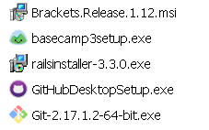



Byebug

sinatra